Arrange the numbers 1 to 6 in each set of circles below.
The sum of each side of the triangle should equal the number in the centre of the triangular shape.
How are you going about trying to find an arrangement that works?

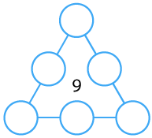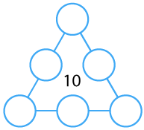

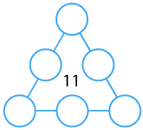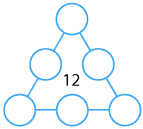
Once you've had a chance to think about it, have a look below to see how three different pupils began working on the task.

Dan said:
"I used counters which had 1 to 6 on them.
I put the counters in a triangle in any old way, then I added up the sides.
Then I moved the counters around to try and get the right total on each side."

Emma said:
"I noticed that three of the numbers are odd (1, 3 and 5) and three of the numbers are even (2, 4 and 6). I thought this might help.
I know that 9 is an odd number so it can be made using odd + odd + odd or using even + even + odd."

Farah said:
"If I want a small total on each side, I'll need small numbers in the corners of the triangle."

Can you take each of these starting ideas and develop it into a solution?

