I started with a clock without hands or lines showing the minutes (except for those where there is a number). The 12 was replaced by a 0 and the numbers placed outside the face.
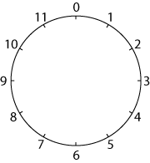
I drew straight lines to join up the numbers.
I started by counting in ones and I got a 12-gon (that is a 12-sided polygon - if you like long words you can call it a dodecagon).
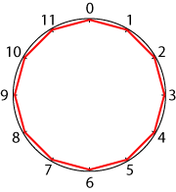
Then I drew straight lines counting round in 2s. And I got ...?
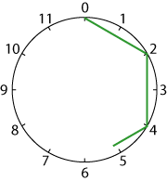

Perhaps you could try without putting the numbers round the circles.
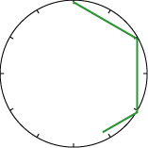
I tried 5s (wow!) and 6s (well!).
Each time I go on drawing lines until I get to the point where I first started.
Then I tried 7s, 8s, 9s, 10s, and 11s.
Something interesting was happening.
Why don't you try it? What patterns do you notice emerging?
And what about counting round in 12s?
Which shapes are the same? Can you think of a reason why?
Can you see a connection between the number in which you are counting around the circle and the number of sides in the shape you are making?

