Use these cards to make some number sentences:
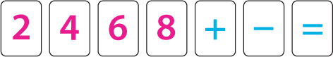
For example:
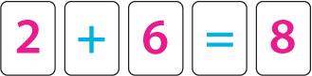
In each number sentence you must only use a card once, but of course you can re-use them in your next number sentence if you want to.
Can you find a way to use all the cards in one number sentence?
Can you find all the possible ways to use the cards?

