In the diagram below (which is not drawn to scale), the area of the three triangular regions is given.
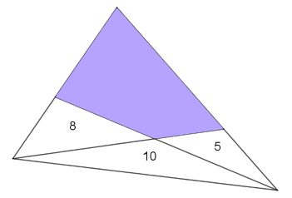
Can you work out the area of the shaded quadrilateral?

Perhaps it feels as though there isn't enough information to solve this problem! If you are stuck, have a look at the suggestions below.

4 6

2 3
First suggestion

What is the relationship between the ratio of the two areas and the ratio of the two lengths?

Can you explain why?
Can you apply this to the original problem?
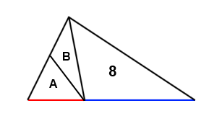
Second suggestion

The red line (the base of the triangle with area A) is half the length of the blue line (the base of the triangle with area 8). What can you say about A+B ?
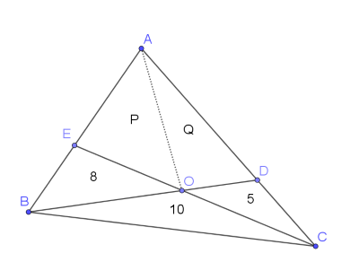
Third suggestion

It might be useful to label the points in the diagram. You could also split the quadrilateral into two triangles, and label them:
Can you use the ideas from the first two suggestions to write down some relationships in terms of P and Q?

