In the diagram below (which is not drawn to scale), the area of the three triangular regions is given.

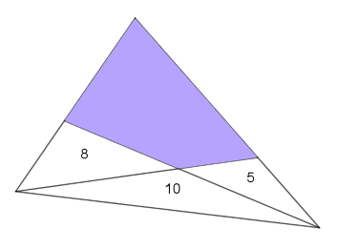

Can you work out the area of the shaded quadrilateral?

